**SPH3U 5.2 Energy**

1. **Kinetic energy**

|  |  |
| --- | --- |
| Energy: |  |
| kinetic energy |  |
| equation |  |

Where does this value come from? Consider the amount of work it takes to change speeds.

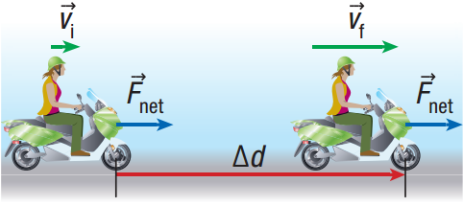Imagine a motorcycle moving at a constant speed, which then accelerates to a new speed. To accelerate, it must have a force acting on it. What is the work done by this force? Assume that all you know is the mass of the motorcycle, its initial speed, and its final speed.

How much work is done to accelerate from rest to some final speed (vi = 0)?

Calculate the kinetic energy of a 150 g baseball that is traveling toward home plate at a constant speed of 35 m/s.

1. **The relationship between mechanical work and kinetic energy**

What is the work done to change from one speed to another?

This is called the **work-energy principle**.

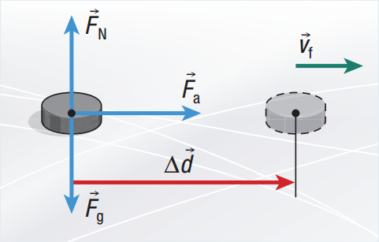A 165 g hockey puck initially at rest is pushed by a hockey stick on a slippery horizontal ice surface by a constant horizontal force of magnitude 5.0 N (assume that the ice is frictionless). What is the puck’s speed after it has moved 0.50 m?

1. **Gravitational potential energy: A stored type of energy**

|  |  |
| --- | --- |
| Potential energy: |  |
| gravitational potential energy |  |
| equation |  |
| reference level |  |

Where does this value come from? Consider the amount of work it takes to lift something.

Imagine lifting a textbook off your desk at a constant speed (not accelerating). Remember, this means that forces are balanced (Fnet = 0). How much work is done by the applied force?

What is the gravitational potential energy of a 48 kg student at the top of a 110 m high drop tower ride relative to the ground?

1. **Mechanical energy**

|  |  |
| --- | --- |
| Mechanical energy: |  |

**Homework:** page 235: #1-3, 5